Outlines:
Objectives 2
Exercise 1 : Setting up a dashboard in Excel 2
Exercise 2 : Configuring a dashboard layout in Excel 3
Finally your dashboard should look similar to the image below: 6
Link to completed work 7

Objectives
After completing this lab, you will be able to:
- Set up a dashboard in Excel.
- Configure a dashboard layout in Excel.

Exercise 1 : Setting up a dashboard in Excel
In this exercise, you will learn how to set up a simple dashboard with visualizations in Excel.
- Download the file Car_Sales_Kaggle_DV0130EN_Lab3_Start.xlsx. Upload and open it using Excel for the web.
- Click + to add a new worksheet, then double-click Sheet1 tab and rename it to Dashboard, then click OK.
- Drag the Dashboard tab to the far right of the workbook tabs if needed.
- Select the Column, Pie, Sunburst Chart worksheet tab.
- Select the Column chart and press CTRL+C.
- Select the Dashboard tab, click somewhere in the middle of the sheet, and press CTRL+V.
- Select the Column, Pie, Sunburst Chart worksheet tab.
- Select the Pie chart and press CTRL+C.
- Select the Dashboard tab, click somewhere in the middle of the sheet, and press CTRL+V.
- Select the Column, Pie, Sunburst Chart worksheet tab.
- Select the Sunburst chart and press CTRL+C.
- Select the Dashboard tab, click somewhere in the middle of the sheet, and press CTRL+V.
If you have a copy of Excel Desktop you can continue on here and do both exercises using the first start file provided.
Note: Excel for the web cannot copy slicers and pivot charts, so if you are using a version of Excel for the web, you will need to stop this exercise here, then open the provided Car_Sales_Kaggle_DV0130EN_Lab3_Ex2Start.xlsx file, and then continue from Exercise 2 Step 1 below.
- Select the Column, Pie, Sunburst Chart worksheet tab.
- Select the Slicer and press CTRL+C.
- Select the Dashboard tab, click somewhere in the middle of the sheet, and press CTRL+V.
- Select the Bar Chart worksheet tab.
- Select the Bar chart and press CTRL+C.
- Select the Dashboard tab, click somewhere in the middle of the sheet, and press CTRL+V.
- Select the Bar Chart worksheet tab.
- Select the Slicer and press CTRL+C.
- Select the Dashboard tab, click somewhere in the middle of the sheet, and press CTRL+V.
- At the end of this exercise your Dashboard worksheet should look like the image below:
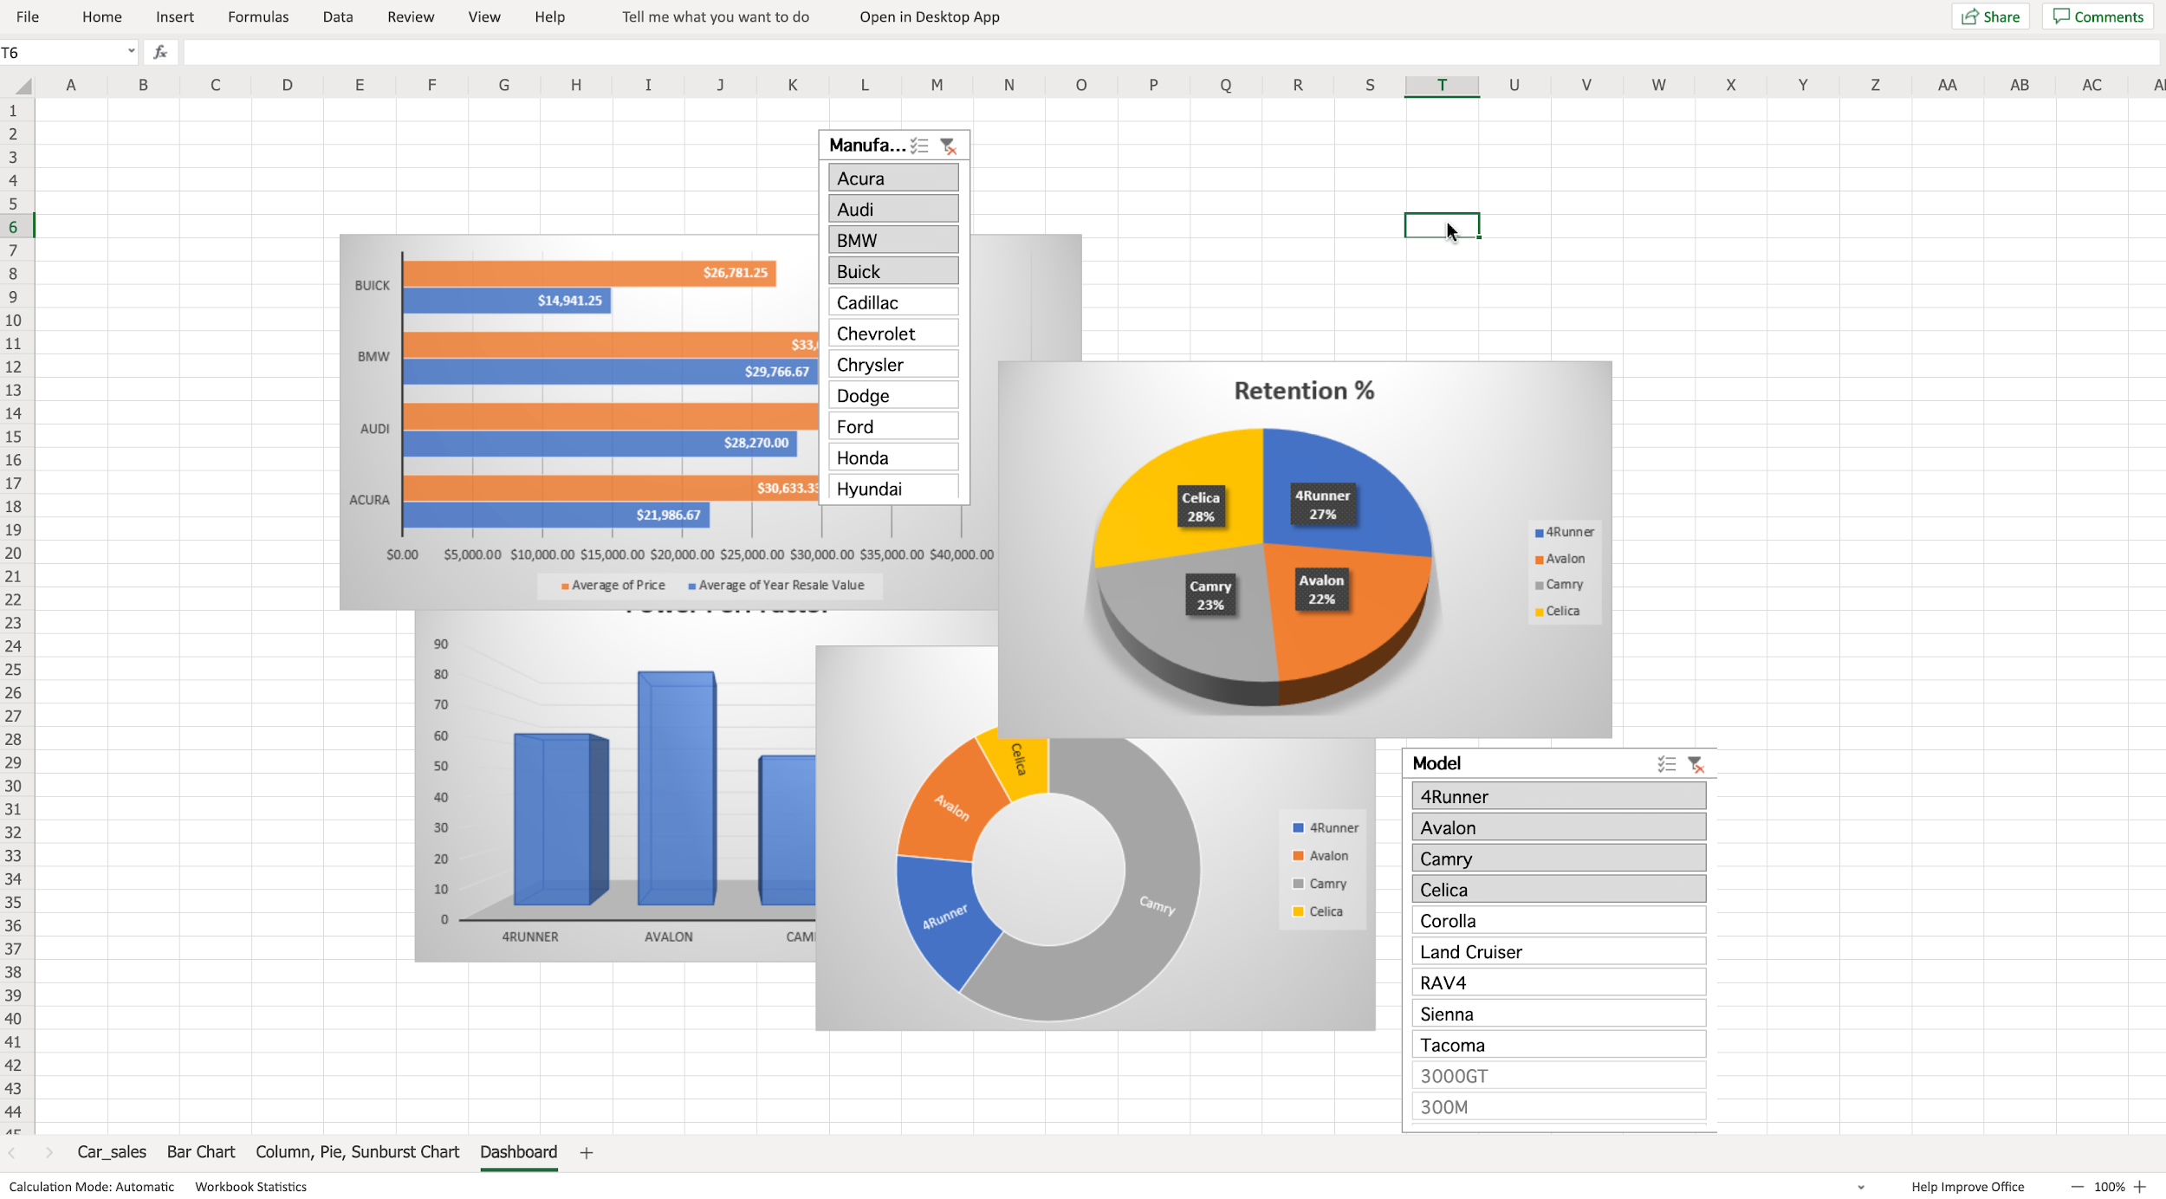

Exercise 2 : Configuring a dashboard layout in Excel
In this exercise, you will learn how to organize and layout the content of a dashboard in Excel.
If you are using Excel for the web, then you need to open the starter file provided in the link above, after Exercise 1 Step 12.
- Select and drag the Bar chart to the top left corner of the sheet.
- Select and drag the Manufacturer slicer to the top of the sheet on the right of the Bar chart.
- Select and drag the Pie chart to the top right of the sheet on the right of the Manufacturer slicer.
- Select and drag the Column chart to the bottom left of the sheet under the Bar chart.
- Select and drag the Sunburst chart to the bottom of the sheet on the right of the Column chart.
- Select and drag the Model slicer to the bottom left of the sheet under the Pie chart.
- Drag and resize all the charts to make them fit better.
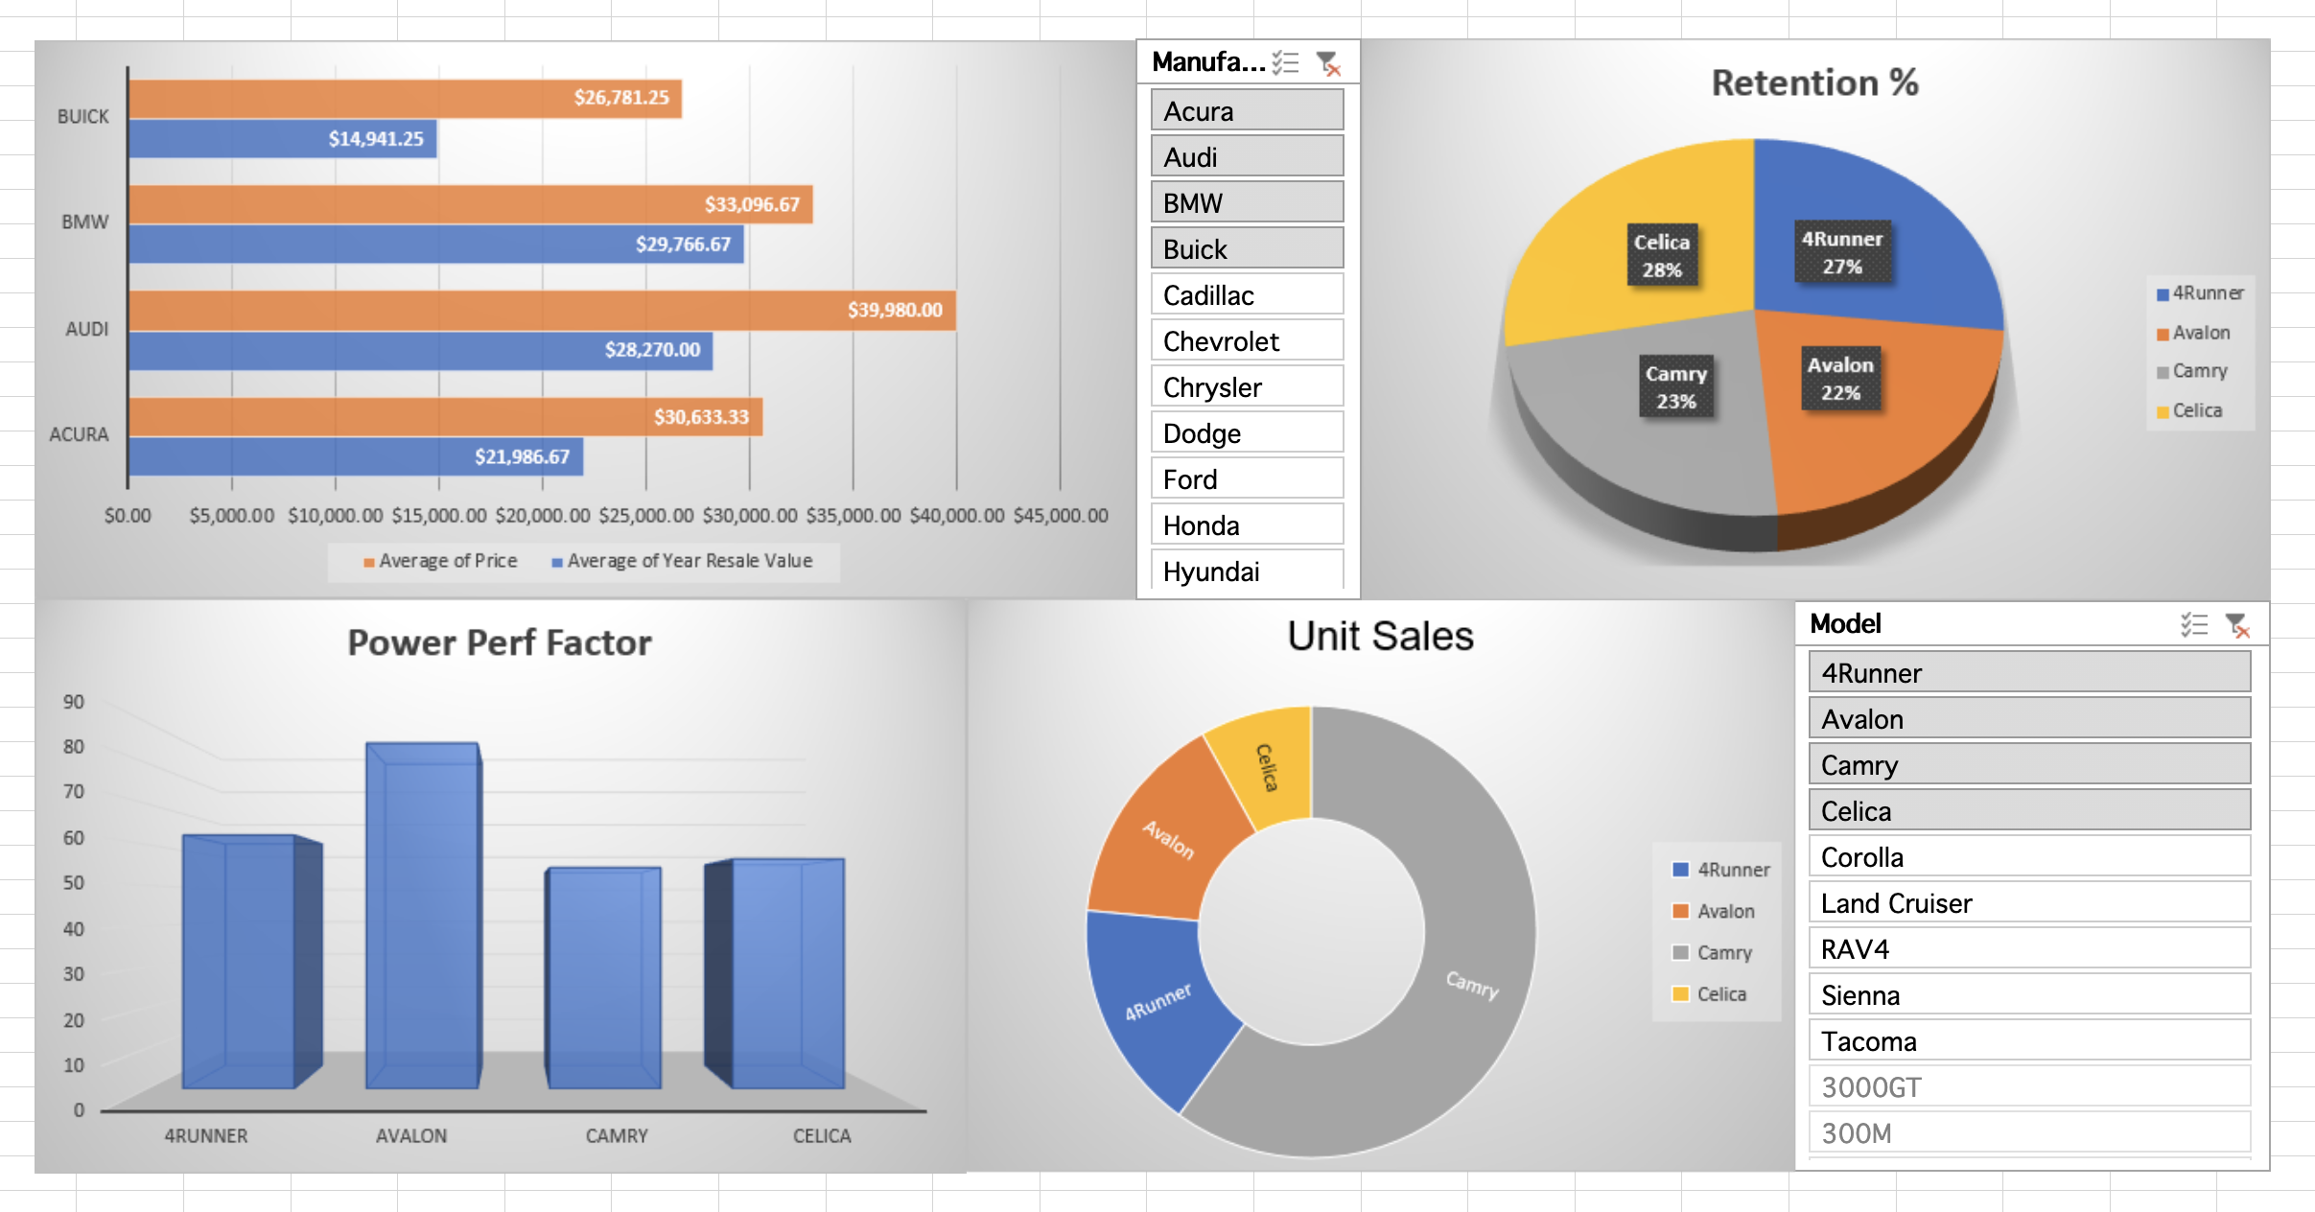

- Select the View tab in the ribbon, and uncheck Gridlines and Headings.
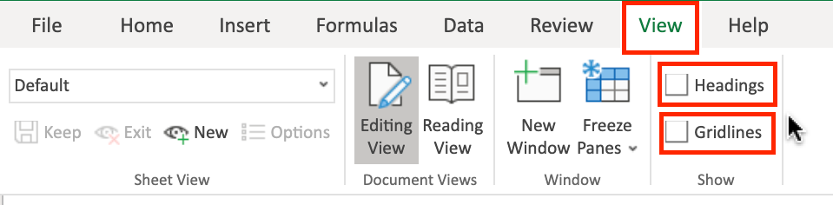

- Double-click any tab to collapse the ribbon.
- In the Manufacturer slicer, select Audi and click the Multi-Select button. Then scroll the slicer and select only Audi, BMW, Mercedes-B, Porsche, Volkswagen.
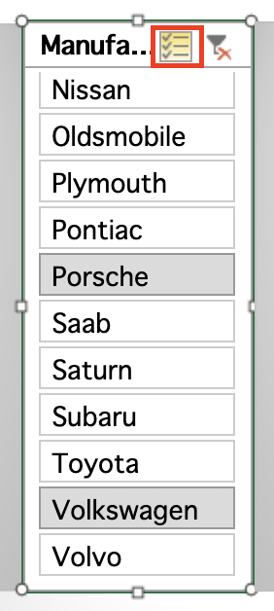

- Click on the Bar chart area to access the Chart tab in the ribbon.
- On the Labels group of the Chart tab, click Chart Title and select Edit Chart Title….
- In the text input area of the dialog box Edit Title, write “Average Price and Year Resale Value of German Car Models” and click OK.
- In the Model slicer, click the Clear Filter button.
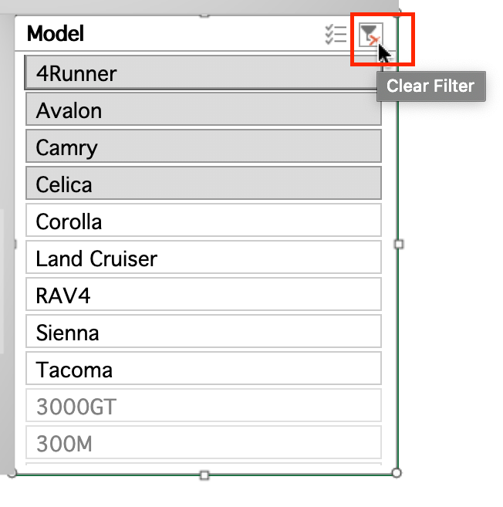

Finally your dashboard should look similar to the image below:
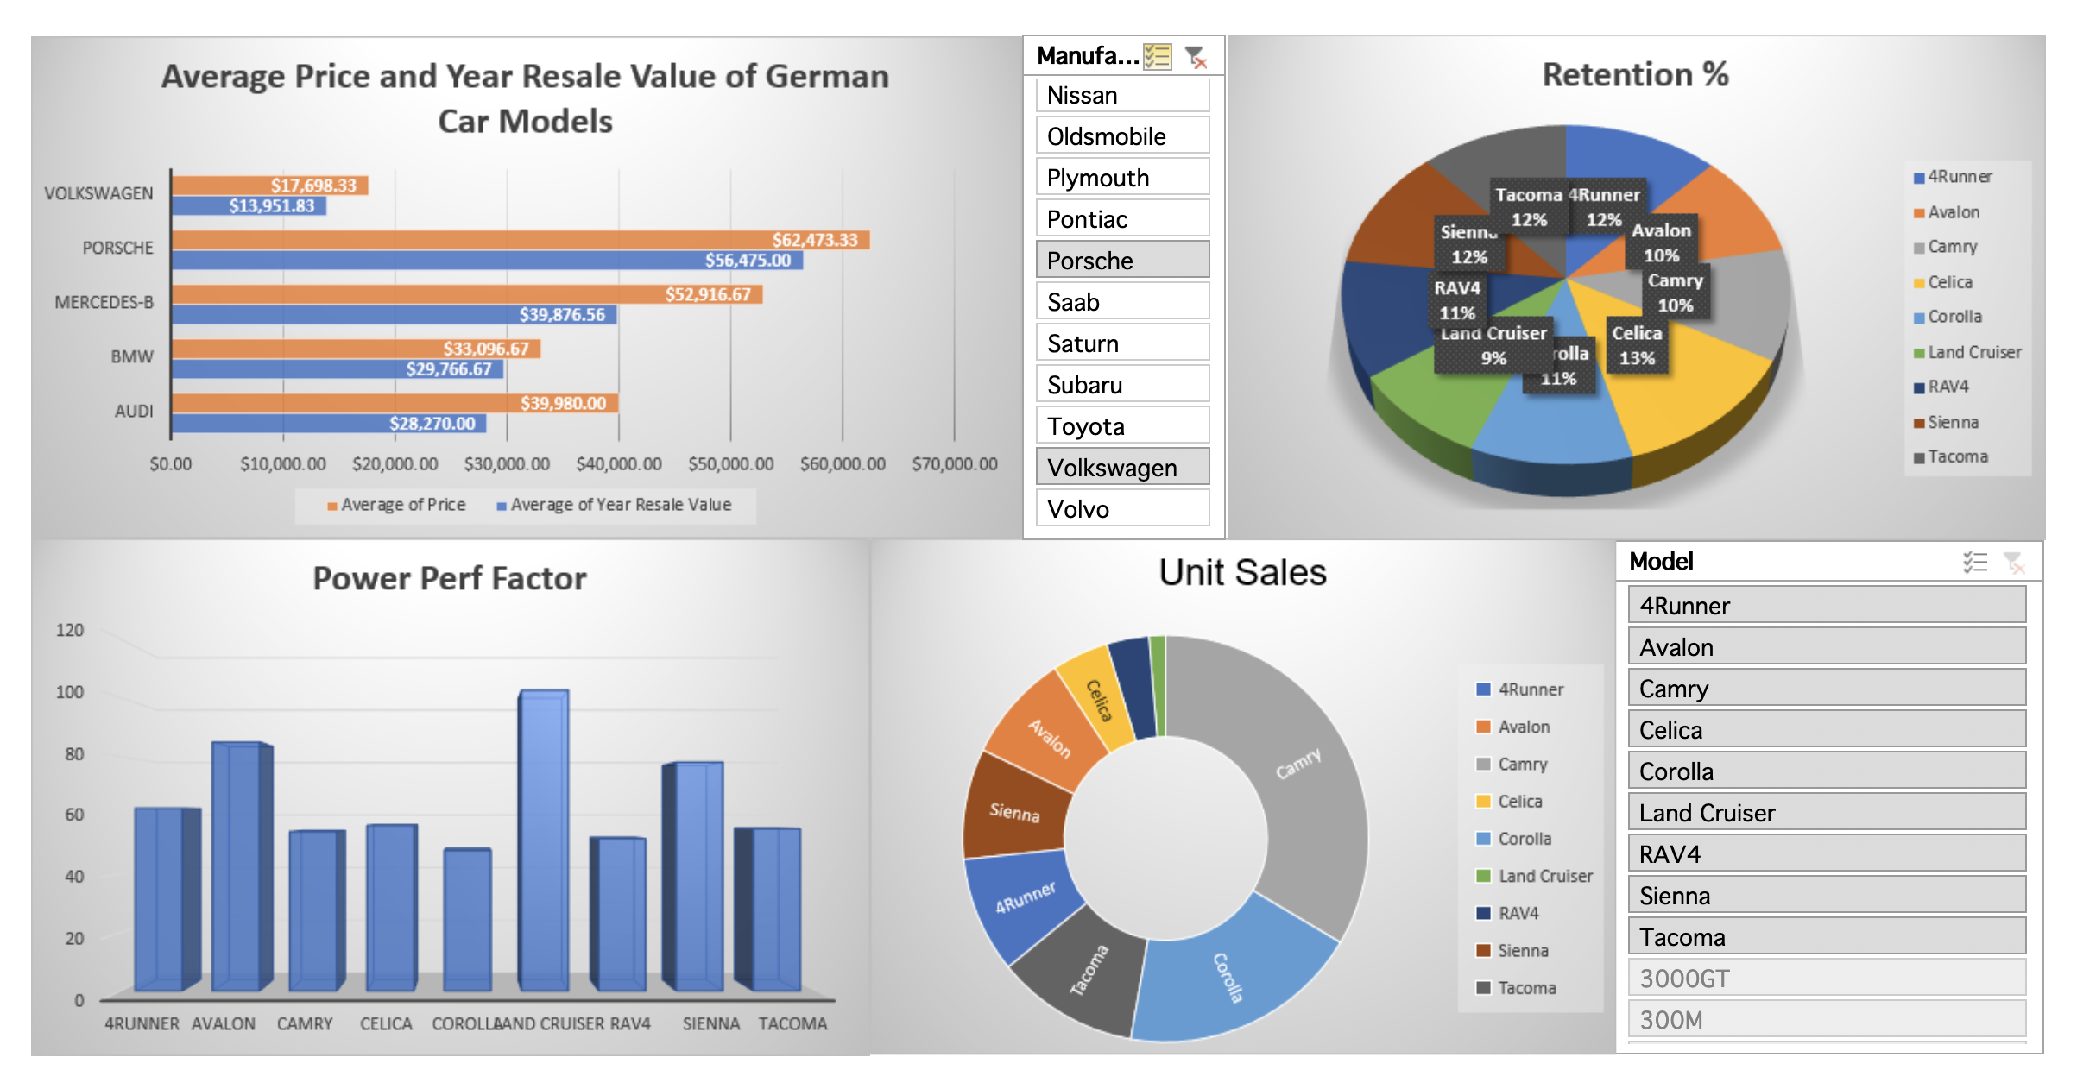

Link to completed work
Please download this file for beter accessibility as the hyperlinks doesnot work in Github.

- https://1drv.ms/x/c/e9e9f77ba9bf99d2/IQBQGzOlaQYgSaIeAFSM7Ge6AWaX9nC06Gb_BrktYnQTzd8?e=xeSB2x
- https://1drv.ms/x/c/e9e9f77ba9bf99d2/IQCw3zHMmFFiSqsoinh2-SVyAZRBiADvyHNpSSqJMkwI4RM?e=Gbe4Sb

